HUMAN REPRODUCTION

HORMONES SECRETED BY PLACENTA

Human chorionic gonadotropin( HCG), Progesterone, Estrogen and human placental lactogen (HPL ). RELAXIN are the hormones secreted by placenta.

Hormones produced by the placenta during pregnancy includes Human chorionic gonadotropin (hCG), human placental lactogen (hPL), estrogens, progestogens, relaxin.

Human chorionic gonadotropin hormone helps in maintaining the corpus luteum during the early stages of pregnancy.

Human placental lactogen promotes mammary gland growth for lactation.

Estrogen hormone helps the uterus grow, maintains the uterine lining and regulates the production of other hormones.

Progesterone helps in thickening the lining of the uterus during pregnancy and providing supportive environment to the foetus.

During delivery, relaxin relaxes the pelvis and widens the cervix.

Correct sequence of hormone secretion from beginning of menstruation is

Before the start of the Menstrual cycle,

The estrogen and progesterone levels are low. Low levels of estrogen and progesterone signal the pituitary gland to produce Follicle Stimulating Hormone (FSH).
FSH begins the process of maturing. The follicle produces more estrogen.

Increased estrogen levels trigger a sharp rise in Luteinizing Hormone (LH) from the pituitary gland, causing release of the egg from the follicle.

The ruptured follicle called the corpus luteum now secretes more progesterone and estrogen to continue to prepare the uterus for pregnancy.

If the egg is not fertilized, estrogen and progesterone levels drop and the menses begin

So, the correct answer is 'FSH, Estrogen, Progesterone'

FSH,ESTROGEN, LH ,PROGESTERONE

IF OVUM IS NOT FERTILIZED

If mammalian ovum fails to get fertilised the corpus luteum degenerate. This causes disintegration of endometrium leading to menstruation and a new cycle starts. Progesterone secretion declines and the primary follicle starts to develop again.

GROWTH RATE OF POPULATION

Population of ORGANISMS at time t1

population of organisms 1 hour after t2

Growth rate of a population = t2-t1 per hour

NPP

Amount of organic matter stored (after used up in respiration) by producers per unit time and per unit area is referred to as net primary productivity (NPP). It can be expressed as

NPP = GPP (Gross Primary Productivity) - R (Respiration Losses).

SPECIES RICHNESS

Species richness may be measured by dividing the total number of species by the total area of the defined ecosystem. However, because species richness is sensitive to sampling, the Margalef's index and Menhinick's index were created to calculate species richness independently of the sample size collected.
S = CAz,
where
S = Species richness
A = Area
Z = Regression coefficient ( power value)
C = Y-intercept...

CALCULATION OF RESPIRATION LOSS

GPP – R = NPP
200 – R =100
R = 100 g C/m²/year

Birth rate of population
Newly originated /already existed

initial number of hydrilla = 20

new hydrilla= 10

time period = 1 year

Birth rate = number of birth per year with respect to number of individuals in population= 10/20= 0.5 per year

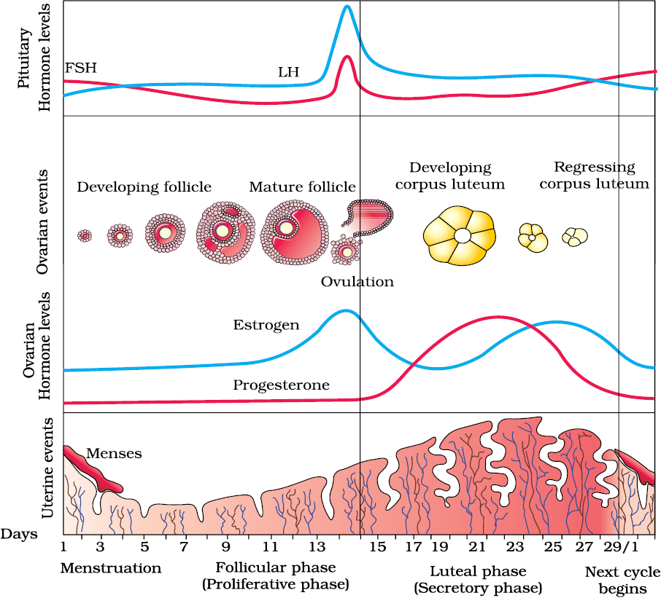

8-12 days | 13 and 15 | 16-23
GnRH from hypothalamus stimulates anterior pituitary to release FSH and LH. | governed by the high LH and FSH levels. | It starts secreting progesterone
FSH stimulates the ovarian follicles to secrete oestrogen, which in turn stimulates the proliferation of the endometrium of the uterine wall. This causes the endometrial lining to thicken. | The endometrium is intact due to the effect of these gonadotropin hormones and also prepares itself for pregnancy, if fertilization occurs. | ruptured Graafian follicle gets converted into corpus luteum in the ovary.  It starts secreting progesterone which maintains the endometrium, necessary for the implantation of fertilised ovum followed by other events of pregnancy.

